**Lab 4 COAL**

**Yousha Mehdi**

**K226007**

**BSR – 3C**

Task 1:

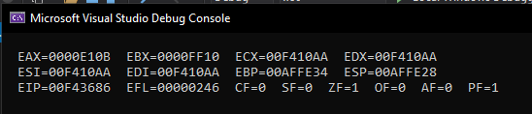

TITLE My First Program (Test.asm)

INCLUDE Irvine32.inc

.data

A DWORD 0FF10h

B DWORD 0E10Bh

.code

main PROC

mov eax, A

mov ebx, B

mov B, eax

mov A, ebx

; New values

mov eax, A

mov ebx, B

call DumpRegs

exit

main ENDP

END main

Task2:

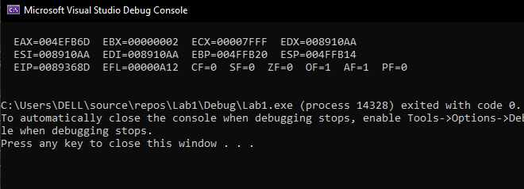

TITLE My First Program (Test.asm)

INCLUDE Irvine32.inc

.data

val1 BYTE 10h

val2 WORD 8000h

val3 DWORD 0FFFFh

val4 WORD 7FFFh

.code

main PROC

;(1)

inc val2

;(2)

sub eax, val3

;(3)

mov ebx, 0

mov ecx, 0

mov bx, val2

mov cx, val4

sub bx, cx

call DumpRegs

exit

main ENDP

END main

Task 3:

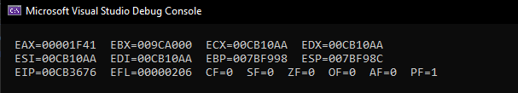

TITLE My First Program (Test.asm)

INCLUDE Irvine32.inc

.data

val1 SDWORD 8000

.code

main PROC

add val1, 1

mov eax, 0

mov eax, val1

call DumpRegs

exit

main ENDP

END main

Task 4:

A,

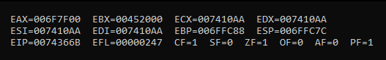

B,

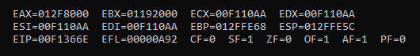

C,



TITLE My First Program (Test.asm)

INCLUDE Irvine32.inc

.data

.code

main PROC

; (a)

mov ax, 7ff0h

add al, 10h

; (b)

add ah, 1

; (c)

add ax, 2

call DumpRegs

exit

main ENDP

END main

Task 5:

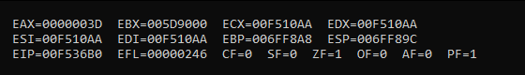

TITLE My First Program (Test.asm)

INCLUDE Irvine32.inc

.data

array BYTE 61,43,11,52,25

array2 BYTE 5 DUP(?)

.code

main PROC

mov eax, 0

mov al, [array + 2]

mov array2, al

mov eax, 0

mov al, [array + 4]

mov [array2 + 1], al

mov eax, 0

mov al, [array + 1]

mov [array2 + 2], al

mov eax, 0

mov al, [array + 3]

mov [array2 + 3], al

mov eax, 0

mov al, array

mov [array2 + 4], al

call DumpRegs

exit

main ENDP

END main

if array is in word indexing will be +2 and al will become ax.

if array is in dword indexing will be +4 and al will become eax.

Task 6:

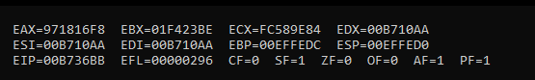

TITLE My First Program (Test.asm)

INCLUDE Irvine32.inc

.data

arrayB BYTE 10, 20, 30

arrayW WORD 150, 250, 350

arrayD DWORD 600, 1200, 1800

sum1 DWORD 0

sum2 DWORD 0

sum3 DWORD 0

.code

main PROC

; ========= SUM 1 =========

mov eax, 0

add eax, DWORD ptr [arrayB]

add eax, DWORD ptr [arrayW]

add eax, DWORD ptr [arrayD]

mov sum1, eax

; ========= SUM 2 =========

mov ebx, 0

add ebx, DWORD ptr [arrayB + 1]

add ebx, DWORD ptr [arrayW + 2]

add ebx, DWORD ptr [arrayD + 4]

mov sum2, ebx

; ========= SUM 2 =========

mov ecx, 0

add ecx, DWORD ptr [arrayB + 2]

add ecx, DWORD ptr [arrayW + 4]

add ecx, DWORD ptr [arrayD + 8]

mov sum3, ecx

call DumpRegs

exit

main ENDP

END main

Task 7:

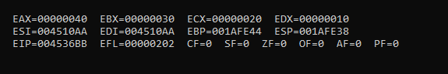

TITLE My First Program (Test.asm)

INCLUDE Irvine32.inc

.data

array1 BYTE 10h, 20h, 30h, 40h

array2 BYTE 4 DUP (?)

tmp BYTE ?

.code

main PROC

mov ecx, 4

mov tmp, 0

my_label:

mov al, [array1 + ecx - 1]

mov edx, 0

mov dl, tmp

mov [array2 + edx], al

inc tmp

loop my_label

mov eax, 0

mov ebx, 0

mov ecx, 0

mov edx, 0

mov al, [array2]

mov bl, [array2 + 1]

mov cl, [array2 + 2]

mov dl, [array2 + 3]

call DumpRegs

exit

main ENDP

END main